**Analyzing US Insurance Claim Data**

**HW3**

**Group 5**

**Roger Hung, Erin Cao, Henry Gao, Stella He, Jiajie Yuan, Robert Malongo**

# **Introduction**

In this assignment, we analyse the US insurance market using Insurance Claim data. In particular we used All-Payer Claim Data (APCDs) for the year 2016. APCDs are databases that include medical claims, pharmacy claims, dental claims, and eligibility and provider files collected from private and public payers. For this assignment, we used four databases. These databases are inpatient file reports, outpatient reports, emergency room reports, and revenue reports.

In our analysis, we start by following the journey of seven patients and their interaction with the healthcare system. For each patient, we identify their demographics, type of illness, doctor diagnosis, services/drugs provided and the costs associated with each diagnosis. We also supplement this analysis with relevant additional information.

We proceed by analysing the services and costs provided by the major insurance providers for inpatient hospitalizations. The major insurance providers are Medicare, Medicaid, and Commercial Payers (Blue Cross and Commercial Insurance). Here we calculate the total costs for these major insurance providers across the 25 Major Diagnostic Categories(MDC).

Lastly, we analyse the severity of illicit drugs and prescription drugs overdose in the US using the emergency room data. We calculate the size of ED visits related to drug abuse and the associated type of diagnosis. We also analyse the distribution opioid and drug abuse across gender and location in the US.

# 

# **Results and Discussions**

## Question 1: Patient vignettes

### **ID: 507033**

This is a female patient within the age of 25-29 who lives in a city/town in Vermont. She voluntarily left her home and went to Northwestern Medical Center in the state. This patient went to the hospital as she was in labor. She was diagnosed with a 40 week pregnancy due delivery. The doctors at the hospital rendered to her two services namely *“Delivery of Products of Conception, External Approach*” and “*Drainage of Amniotic Fluid, Therapeutic from Products of Conception, Via Natural or Artificial Opening”*. The patient successfully conceived a baby while admitted at the hospital. Her delivery proceeded without any complications and she was discharged home the following day.The costs associated with this trip came up to $3,233.29 with labor room charges accounting for the most at 39.4% ($1273.76). Here is a detailed breakdown of the costs that she incurred.

Room & Board -Semi-Private 2 beds ($1002.13); Clinical Diagnostic ($341.00); Medical/Surgical Supplies: Sterile supplies ($334.33); Pharmacy: IV solutions ($92.10), Pharmacy ($83.44); Medical/Surgical Supplies ($75.22); and Pharmacy: Other ($31.31). Her principal payment source for this hospital visit is Blue Cross Insurance Company. Across the US, a baby delivery without complications costs $2,600 for those with health insurance. This brief exercise suggests that the cost of having a baby in Vermont might be higher than in other states.

### **ID: 40436**

This patient, served by University of Vermont Medical Center, was transferred from a skilled nursing facility. This patient is an older lady, aged 70-74. The admission type is urgent. Doctors diagnosed that the patient had Atherosclerotic heart disease of native coronary artery without angina pectoris and Type 2 diabetes mellitus with diabetic neuropathy. In addition, this patient was diagnosed with Acute posthemorrhagic anemia, Hyperlipidemia and Unspecified asthma. This patient has some medical history that cannot be ignored. For example, this patient has Personal history of transient ischemic attack (TIA), cerebral infarction without residual deficits, and Family history of ischemic heart disease and other diseases of the circulatory system. After diagnosis, she underwent Percutaneous transluminal coronary angioplasty (PTCA), which are operations on the cardiovascular system. She just stayed in hospital for 1 day and was discharged home after that. Her primary payment source was MEDICARE and the total cost was $70,275.41. The cost includes Room & Board ($1692), Pharmacy ($293.61), Medical/Surgical Supplies: Sterile supplies ($741.33), Medical/Surgical Supplies: Other implants ($10146.5), Laboratory-Clinical Diagnostic ($2226.59), Radiology Diagnostic ($348.82),Nuclear Medicine:Diagnostic($5065),Diagnostic Radiopharms($784), CT Scan:body ($4112.29),Other Imaging Services :Ultrasound ($764.38) ,Cardiology ($23,275.4) ,Cardiology: Cardiac catheter lab($8387.29),Cardiology: Stress test($238),Cardiology: Echocardiology ($2142.82),Drugs Require Specific ID: Drugs requiring det ($5703.7),Drugs Require Specific ID: Self admin drugs ($301.74),EKG/ECG ($104),Treatment/Observation Room: Observation room($3948).

### **ID: 859382**

In 2016 Q2, a male patient, aged between 30-34, living in 05700-05799 zip range, was first accepted by the emergency department of Rutland Regional Medical Center. His admission type was emergency and the admission source is a non-health care facility point of origin. He was discharged because he died later. His CCS diagnosis group was mental disorder. His primary diagnosis is accidental poisoning by heroin, other diagnosis include Acute respiratory failure with hypercapnia, compression of brain, Opioid dependence, Anoxic brain damage, ventricular fibrillation, and Cardiac arrest due to other underlying condition. The primary procedure is Respiratory Ventilation, other procedures include the Insertion of Endotracheal Airway into Trachea and Performance of Cardiac Output. After these procedures, this patient died on the day of admission or the day after admission. His primary payment source was self-pay. Bill type is hospital-based, inpatient final bill. His total charges was $13128.19, including Intensive care ($4450), Pharmacy ($923.99), Pharmacy IV solutions ($38.99), Laboratory - Clinical Diagnostic ($3339.63), Radiology - Diagnostic ($328), Respiratory Services ($2575.58), Emergency room ($1227) and EKG/ECG ($245).

### **ID: 1585831**

The patient, previously never admitted by any healthcare facility on records, was served by North Country Hospital And Health Center and she lived in Middlebury. This patient was in her early 40s and was finally recorded as “Dead” in the last quarter of 2016. Her admission type was emergency and her principal payment type was Medicaid. She had as many as 19 different diagnoses and 11 discharge on record. The patient had been diagnosed as unintentionally poisoning by heroin at the very first stage. Also, there appeared to be acute respiratory failure with hypoxia, acute pulmonary edema and acute and subacute infective endocarditis in her diagnosis. We believe that the condition of the patient was quite complicated. She had a record of Failure of sterile precautions during infusion or transfusion, opioid dependence, uncomplicated, reimbursement purposes, poisoning by benzodiazepines, cardiac arrest due to other underlying condition, neurogenic shock, etc.. For her discharge records, the patient first had intensive care of one unit and cost $4450. Later, in Pharmacy she had IV solution and other expenses, costing her $5600 respectively. In Med supplies charged to patient there was 5500 charges for Medical/Surgical Supplies. Among all charges on records, Emergency room was the most, being $6100. The total charge of her procedure was $17093.8 and her bill type was Hospital base, Inpatient final bill.

### **ID: 200760**

The patient, served by University of Vermont Medical Center, was from non-health care facility point with emergent health condition. She, a 18-24 years old young lady, had gone through a motor-vehicle accident. She accepted diagnosis in the medical center where it was found that displaced fracture of medical malleolus of left tibia and unspecified fracture of shaft of left fibula. During the diagnosis process, doctor also diagnosed that the patient had major depressive disorder and gastro-esophageal reflux disease. After that, the doctor gave her a reposition on left tibia and fibula with internal fixation device. She stayed in the hospital for 4 days and was discharged home afterwards. Her charge by the hospital was over $49K, whose costs included Room & Board ($6768), Pharmacy ($1387.36), Medical/Surgical Supplies: Sterile supplies ($409.96), Medical/Surgical Supplies: Other implants ($10696.77), Laboratory-Clinical Diagnostic ($610.08), Radiology Diagnostic ($833.28), Operating Room Services ($14055.8), Anesthesia ($2590.07), Physical Therapy ($138.63), Physical Therapy: Evaluation/re-evaluation ($350.34), and Emergency Room ($2582.43). The costs were covered by her commercial insurance.

### **ID: 3692**

The patient with ID 3692, a young male, whose age is between 18-24, was transferred to the University of Vermont Medical Center from a non-health care facility due to urgent issues. When admitted to the medical center, he was first accepted by the emergency room and was diagnosed as having mental disorders. The primary diagnosis included bipolar disorder, suicidal ideations, traumatic brain injury, cannabis dependence, and nicotine dependence, etc.. During his time in the hospital, he underwent a series of alcohol and drug rehabilitation treatments, which involves pharmacotherapy for substance abuse and detoxification services for substance abuse. After a 58-day inpatient hospital stay, he was then discharged home during the time period between October and December in 2016. He had his insurance covered by Blue Cross Blue Shield insurance company. His total charges was $117895.3, including Psychiatric ($106662.00), Pharmacy ($5608.26), Laboratory - Clinical Diagnostic ($1716.92), Radiology - Diagnostic ($1873.08), Emergency Room ($1983.03), and EKG/ECG ($52.00).

### **ID: 690326**

The patient, a middle-aged female with an ID of 690326, whose age is between 40-44, was transferred to the University of Vermont Medical Center from a non-health care facility due to urgent issues. When admitted to the medical center, she was first accepted by the emergency room and was diagnosed as having diseases of the Skin, Subcutaneous Tissue & Breast without complication or comorbidity (CC) or a major complication or comorbidity (MCC). The primary diagnosis included encounter for cosmetic surgery, pruritus, tachycardia, other muscle spasms, and bariatric surgery. During her time in the hospital, she underwent a series of therapeutic procedures on skin and breast. The doctors at the hospital rendered to her two services that are an alteration of bilateral breast and an alteration of the abdominal wall. After a 3-day inpatient hospital stay, she was then discharged home in 2016. She self-paid the bill of all the treatment she received possibly because of the nature of the treatment. Her entire charges was $43425.53, including Room & Board (Semi-Private 2 beds) ($5076.00), Pharmacy ($1351.25), Medical/Surgical Supplies: Nonsterile supplies ($146.18), Medical/Surgical Supplies: Sterile supplies ($642.32), Laboratory - Clinical Diagnostic ($327.75), Laboratory - Pathology ($273.98), CT Scan: Body ($3273.01), Operating Room Services ($25619.89), Anesthesia($4609.64), and Respiratory Services ($111.68).

## 

## **Question 2: Service and Cost Profile Of major insurances**

### **Medicare**

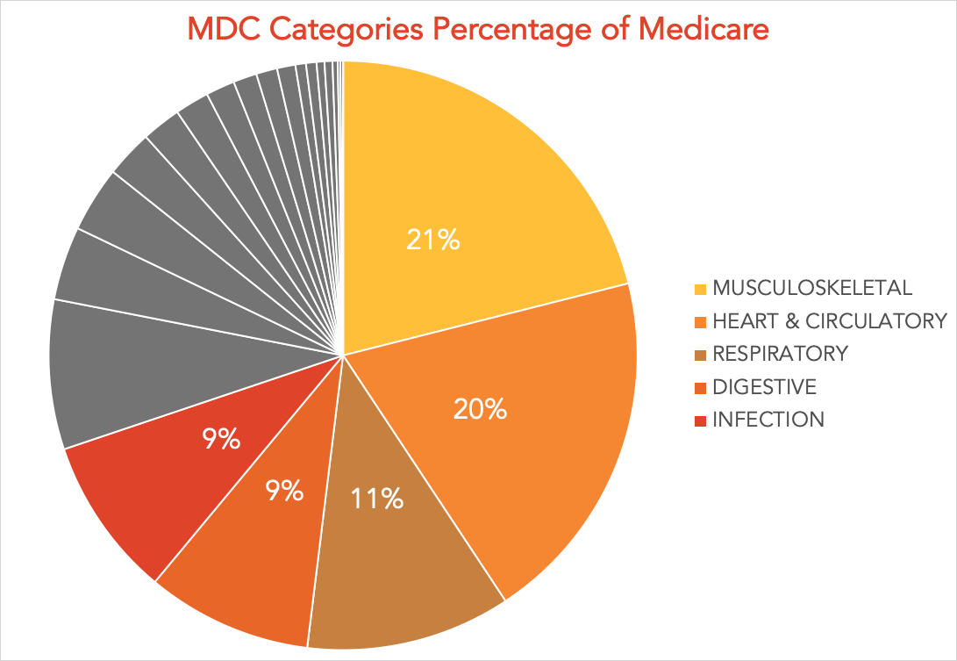

Figure 2.1

Medicare is primarily known as the United States federal health insurance program that is available to the senior US citizen who is 65-year-old or older. On top of this, Medicare also offers health coverage to people who have a disability, regardless of their income. Bearing those thoughts in mind, we hypothesize that the most common MDC’s covered by Medicare reflect the most prevalent diseases among the elder. It comes as no surprise that, as is shown in the pie chart, Musculoskeletal and Heart & Circulatory relevant diseases are the two major problems, together accounting for more than 40% of all major diagnostic categories. Brain & Central Nervous System related diseases come in third place. According to MedlinePlus, as we age, our brains and spinal cord lose nerve cells and weight, and this can cause abnormal changes in the brain called plaques and tangles to form. The fact that aging can affect your senses and possibly lead to diseases further validates our assumption that the major components in the charts are diseases the elder tend to suffer.

### **Medicaid**

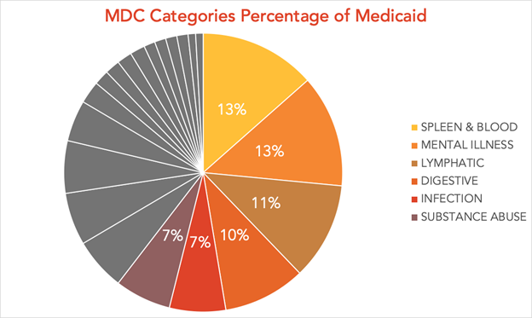

Figure 2.2

Medicaid is different from Medicare, which is a state and federal program that provides health coverage if you have a very low income. From this pie chart, we can notice that SPLEEN & BLOOD and MENTAL ILLNESS have the highest proportion. Our assumption is that low income people may drink more often and not have a particularly stable life, which may lead to spleen & blood problems. Meanwhile, low-income people face huge life pressure compared with middle or high income groups, thus they are more likely to suffer from mental illness. For example,depression is a very common psychological disease, people may suffer from it because of various life shocks, and the poor are more likely to suffer from it than the rich. Lymphatic and digestive diagnoses account for more than 10% of Medicaid services portfolio, which also supports our assumption that the low-income group is more likely to suffer from digestive diseases because it would be more difficult for them to keep a healthy and hygienic eating habits due to poverty. Another MDC category we cannot ignore is substance abuse, which presents 7% of Medicaid services portfolio. Our assumption is that low-income people are more likely to abuse drugs, such as addiction to some dependent or hallucinogenic drugs.

### **Commercial insurers**

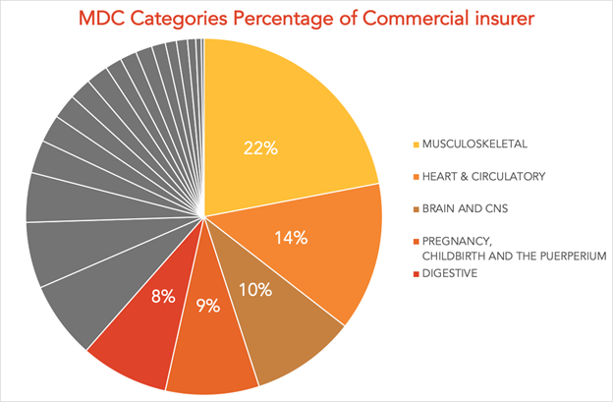

Figure 2.3

Commercial Insurers provide insurance to everyone who is ineligible for Medicare and Medicaid. These would predominantly be adults below the age of 65 with relatively healthy lifestyles. The proportion of men in this coverage might also be higher since some adult women(pregnant women) are eligible for Medicaid. Consequently, our hypothesis would be that the most common MDC’s covered by Commercial Insurers reflect the most common diseases among adults. The pie chart above supports this assumption with *Musculoskeleta*l diagnoses being the highest at 13% of Commercial Insurers’ inpatient services portfolio. The incidence rate for these ailments such as accidents, falls, fractures, and dislocations is higher since most people in this age group are more likely to live an active lifestyle. *Brain & Central Nervous System* diseases and *Heart & Circulatory* diseases are also common in this age group. More importantly, adults in the group are in the child-bearing stage of their lives. Therefore it is not surprising that *Pregnancy, Childbirth, and Puerperium* hospitalizations are in the top five with 9% of all charges for Commercial Insurers.

## **Question 3: Illicit drugs and prescription opioids use/abuse/overdose**

**Drug use/abuse situation:**

Drug overdose has become a severe problem in the US causing many unnecessary cost and losses. Therefore, we were curious about how many ED patients in our data set had been drug abuse. After processing the data, we found 2151 ED visits have been diagnosed as drug user/abuser.

**Gender bias:**

We also want to check if men and women have significant differences in drug using/abusing. In our case, all the N/A values in “sex” column had been dropped. After aggregation, we got the data as below and applied Fisher Exact test:

|  |  |  |  |
| --- | --- | --- | --- |
|  | **Male** | **Female** | ***Total*** |
| **Not drug use/abuse** | 123149 | 140553 | **263702** |
| **% within** | 46.3% | 52.9% | **99.2%** |
| **Drug use/abuse** | 1009 | 1141 | **2150** |
| **% within** | 0.38% | 0.42% | **0.8%** |
| ***Total*** | **124158** | **141694** | **265852** |
| **% total** | **46.7%** | **53.3%** | **100.0%** |

Table 3.1 Fisher Exact test results

Odds ratio = 0.99, P-value = 0.84

**Analysis:**

According to the cross table above, there are small differences in drug use/abuse between male and female patients. After Fisher Exact testing, we found no statistically significant gender bias on drug use/abuse as the p-value was greater than 0.05, which means women have no better protection measures to stay away from drug use/abuse than men.

**Payment on drug overdose:**

There are tens of millions of dollars reportedly spent on drug use related cases the year alone. Below listed the exact dollar amount for identified patients and the share of each of the total payment of Medicare, Medicaid and Commercial Payers.

|  |  |
| --- | --- |
| **Type of Insurance Company** | **Amount** |
| Medicare | **17237917.63** |
| Medicaid | 6713846.42 |
| Commercial Payers | 5777497.88 |
| Total Payment | **30741219.53** |

Table 3.4

Medicare companies take up more than half of the payment and Medicaid has slightly more than Commercial companies.

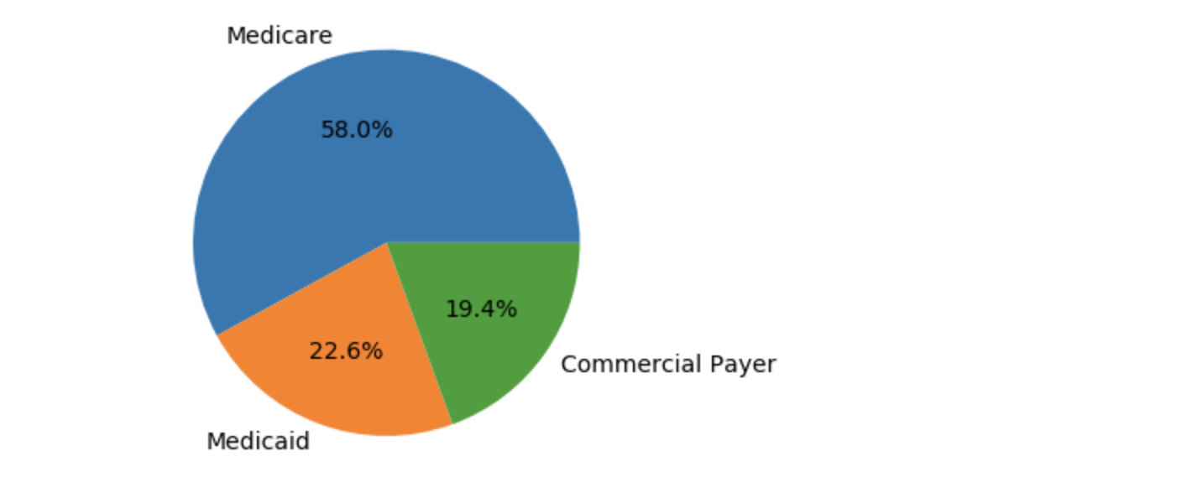

Figure 3.1 Amount share across Medicaid, Medicare and commercial players

**Synthetic Narcotics Related Issue:**

The use of synthetic narcotics is rising alarmingly in part due to the marketing campaign for such meds. There were **156** cases on record that patients were brought to ED for diagnosis related to synthetic narcotics or amphetamines.

**Top 3 Zip code regions in drug abuse:**

|  |  |  |
| --- | --- | --- |
| Zip | Detail | Number of cases |
| 054 | Zip in 05400-05499 range, excluding Burlington to Saint Albans | 326 |
| 057 | Zip in 05700-05799 range, excluding 05701 | 214 |
| 05701 | Rutland | 181 |

Table 3.2 Top 3 Zipcode regions in drug abuse

**10 most common diagnoses of drug abuse**:

|  |  |  |
| --- | --- | --- |
| Diagnosis code | Detail | Number of cases |
| T401X1A | Poisoning by heroin, accidental (unintentional), initial encounter | 258 |
| T402X5A | Adverse effect of other opioids, initial encounter | 256 |
| T424X2A | Poisoning by benzodiazepines, intentional self-harm, initial encounter | 123 |
| T424X5A | Adverse effect of benzodiazepines, initial encounter | 114 |
| T40605A | Adverse effect of unspecified narcotics, initial encounter | 112 |
| T43222A | Poisoning by selective serotonin reuptake inhibitors, intentional self-harm, initial encounter | 82 |
| T402X1A | Poisoning by other opioids, accidental (unintentional), initial encounter | 81 |
| T424X1A | Poisoning by benzodiazepines, accidental (unintentional), initial encounter | 80 |
| T426X5A | Adverse effect of other antiepileptic and sedative-hypnotic drugs | 75 |
| T426X2A | Poisoning by other antiepileptic and sedative-hypnotic drugs, intentional self-harm | 74 |

Table 3.3 Top 10 most common diagnoses of drug abuse

**Analysis:**   
After summarizing the drug abuse data, we found that the most zip code regions where most drug abuse cases happen are zip codes starts with 054 and 057 (Burlington and Rutland). The most common diagnoses of drug abuse in the emergency department include heroin, opioids and benzodiazepines.

# **Conclusion**

The analysis on patient vignettes has enlightened us on the reasons patients can visit a hospital. We have learned how healthcare providers capture and manage information associated with each patient visit. More importantly, we have discovered some of the most expensive one-time services/products that hospitals can provide to a patient. These include cardiology ($23,275), body implants($10,696) and psychiatric services ($10,666).

Our analysis also shows that there is variation in the inpatient services portfolio among Medicare, Medicaid, and Commercial insurers. Our results show that Spleen and Blood illnesses are the most common MDC for Medicaid. On the contrary, Musculoskeletal illnesses are the most common MDC for both Medicaid and Commercial insurers with a share of 22% and 21% respectively. This variation in the top five MDCs is mostly attributed to the demographics of patients under coverage in each insurance type. Medicare has more MDCs associated with older people, Medicaid has more MDCs common among lower income individuals, and Commercial insurers have more MDCs common among healthy adults.

The Emergency Department data shows 2151 ED visits have been diagnosed as drug overdose. Our analysis presents no statistical evidence on gender bias on drug abuse. After summarizing the drug abuse data, we found that 156 patients were brought to ED for diagnosis related to synthetic narcotics or amphetamines. Also, Most drug abuse cases happened in Burlington and Rutland and the most common diagnoses of drug abuse in emergency department include heroin, opioids and benzodiazepines. Besides, it is presented that Medicare companies take up more than half of the payment in emergency department, and Medicaid takes over one fifth and has slightly more than Commercial companies.

# 

# **Recommendation**

ACPDs collect and store patient and provider claims data including the amount charged to patients and paid by payers. “You can’t manage what you can’t measure.” Based on the current database, we recommend policymakers and hospital admissions make ACPDs more transparent tools and provide patients and healthcare service researchers with critical information in a timely manner.

According to our analysis, the top 3 MDC categories, Musculoskeletal, Heart & Circulatory and Respiratory, charged by medicare insurance companies are not covered by any of the major categories of Medicaid insurance, while commercial payers share some common major services with both medicare and Medicaid but still have their own focus. Different insurance companies have their own target services. In this case, on the patients’ behalf, it is important to understand the insurance options, rights, and protections and learn how to get a fast appeal for Medicare-covered services needed, especially for those elders in our family. For the payers, there are also some takeaways from the data. Stockholders can find services that are most demanded and design insurance packages that are more customized for their target market.

Drug overdose causes too many costs and losses. There are more than 2000 cases reported with drug use/abuse issues. Both government and payers should keep an eye on the providers’ records of drugs overdose while choosing hospital or health service facility they cooperate with. Also, there should be penalty for providers that are involved with this issue frequently.

# 

# Reference

* <https://dexur.com/icd10/T401X1A/> -ICD 10 Diagnosis Codes
* <https://www.findacode.com/cpt-code-set.html> -CPT Procedure Codes

# Appendix

* [HW3_q2_Code](https://drive.google.com/file/d/16MWcEwtupoefOJIxK59fN28SEW_QvwdN/view?usp=sharing)
* [HW3_q3_part1](https://drive.google.com/open?id=1tQfGhjhiRskh55ZUDY4USSUJA7WophXO)
* [HW3_q3_part2](https://drive.google.com/open?id=1Gpm_NFlMFPOdJfkMfhSJX4bEovGGU6Qy)
* [HW3_q3_part3](https://drive.google.com/drive/u/1/folders/1Qn7llkYccPMBbuGTLhOmNKy_YHvRAXhA)

END